COMPUTER SCIENCE

COURSE CODE: CSE2015

Source code Management

Handled by: Dr. Monit Kapoor

Amity university

Bengaluru

Name: chilla meenaamrutha

Enrollment number: A86605224083

Course: B.tech CSE

Sem: 2 sem

DATE:30-01-25

Steps involved in installing Git on your laptop.

Step No. 01:

* Open chrome/edge or any browser on your laptop and search for “progit” in it.

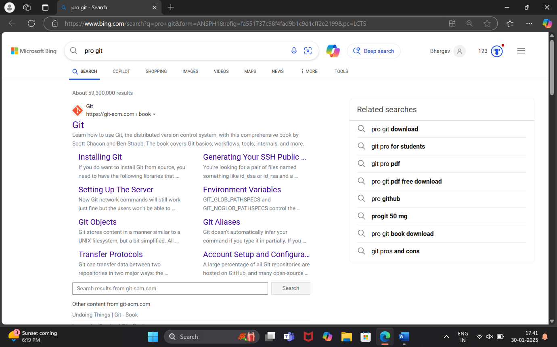

* Then click on the first web link that appears.

Step No. 02:

* Now click on section “1.5 installing git”.

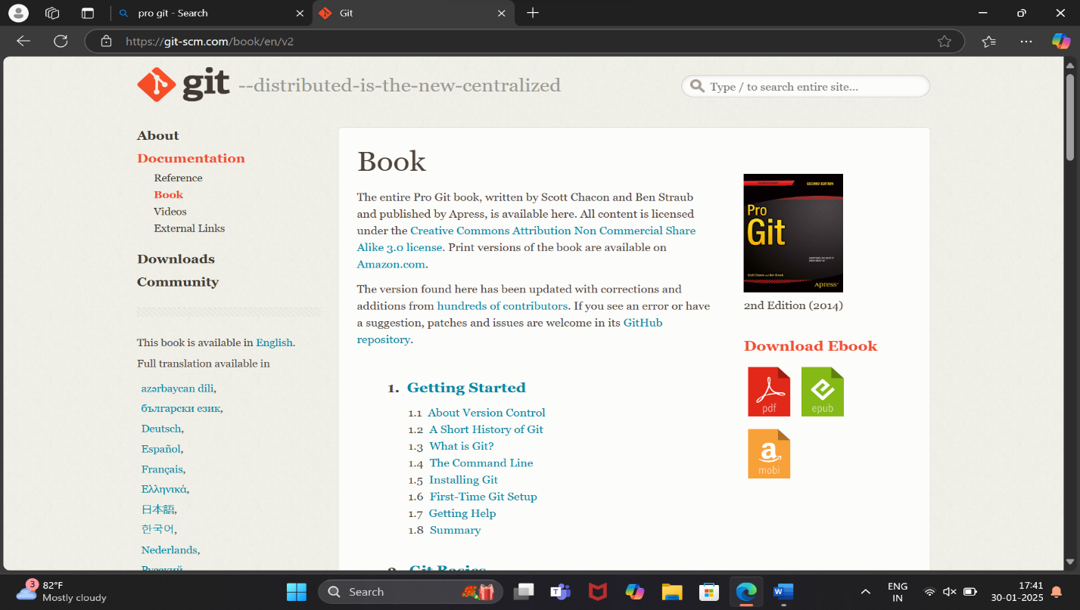

Step No. 03:

* Then scroll a bit down and click on the link

“<https://git-scm.com/download/win>”.

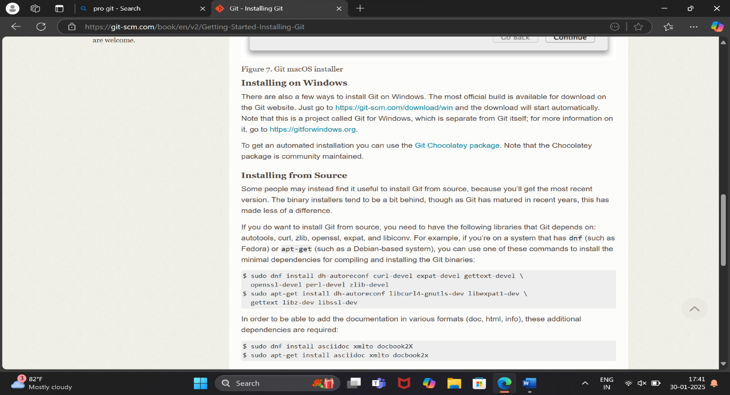

Step No. 04:

* In the next page then click on the version that you want to download.

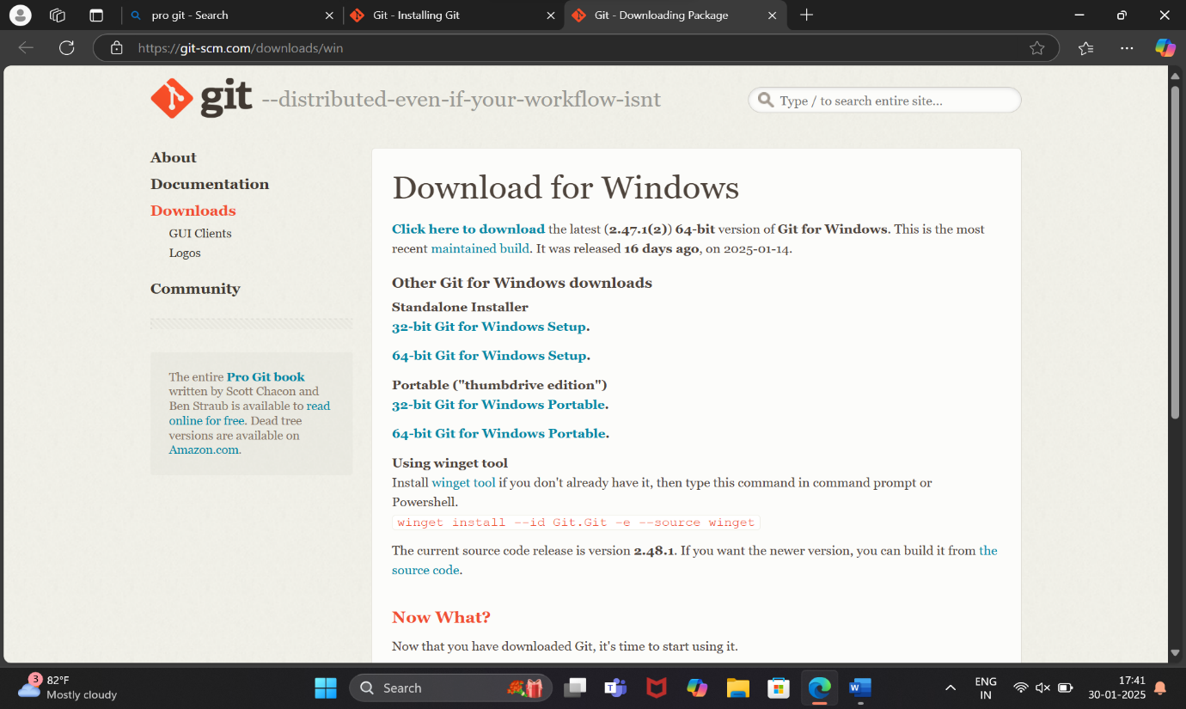

* After the download is completed an page like this will show on desktop which is the general public license of git and part of git setup.

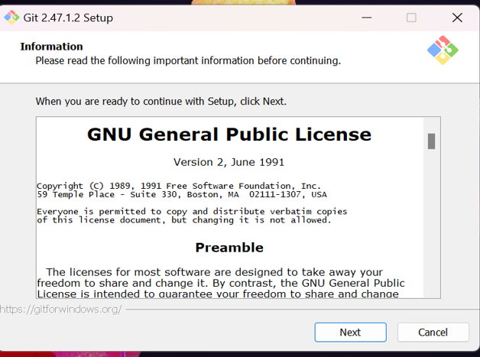

Step No. 05:

* Then after clicking on “next” you can choose where you want the file to be installed.

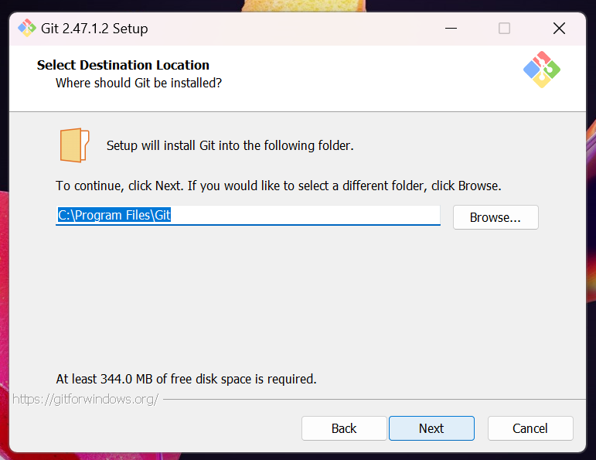

Step No. 06:

* After continuing from here you will be asked on which all components to install along with git.

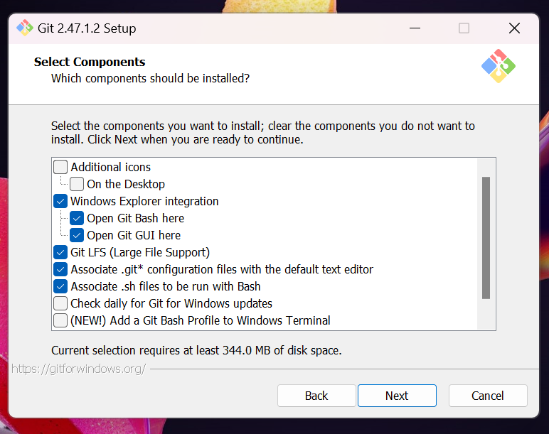

Step No. 07:

* After choosing them you will be asked for creating an short cut and where to save it.

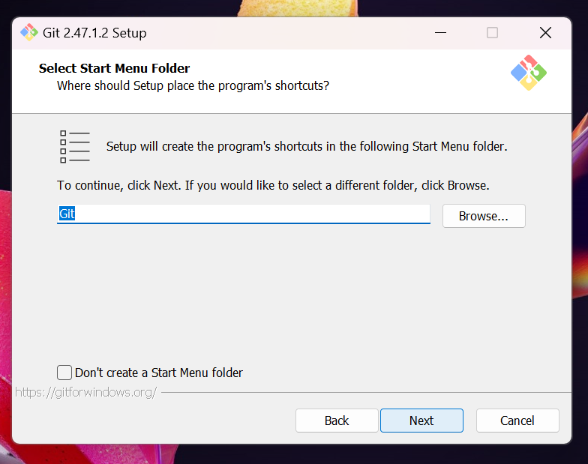

Step No. 08:

* Then you can choose the text editor.

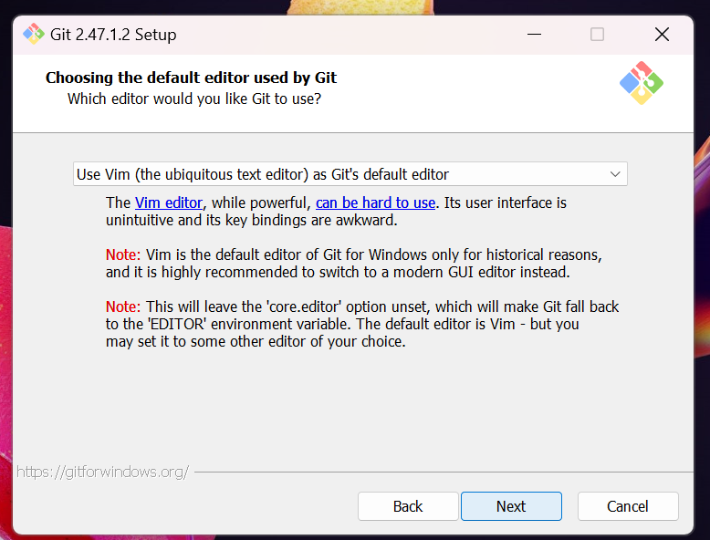

Step No. 09:

* Now here you can choose the initial branch name.

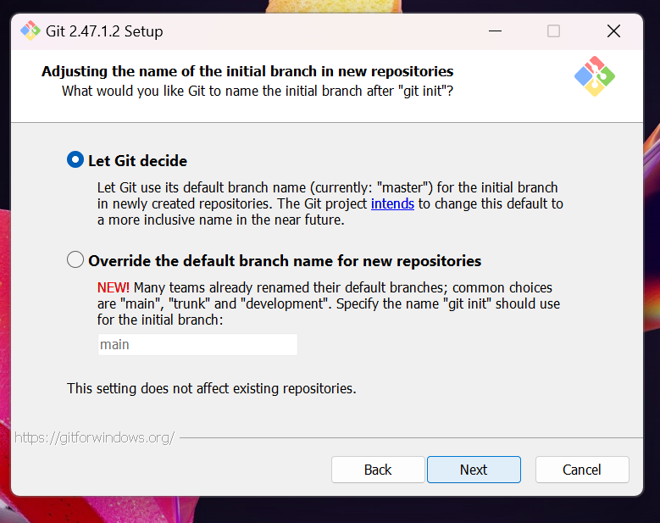

Step No. 10:

* Here the path is being created for git.

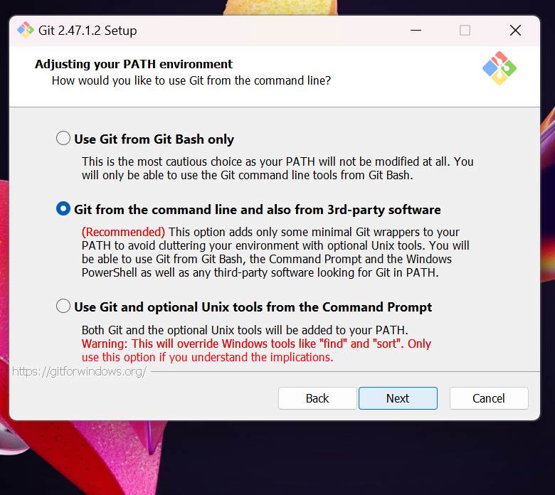

Step No. 11:

* Now SSH is choosen whether external or internal

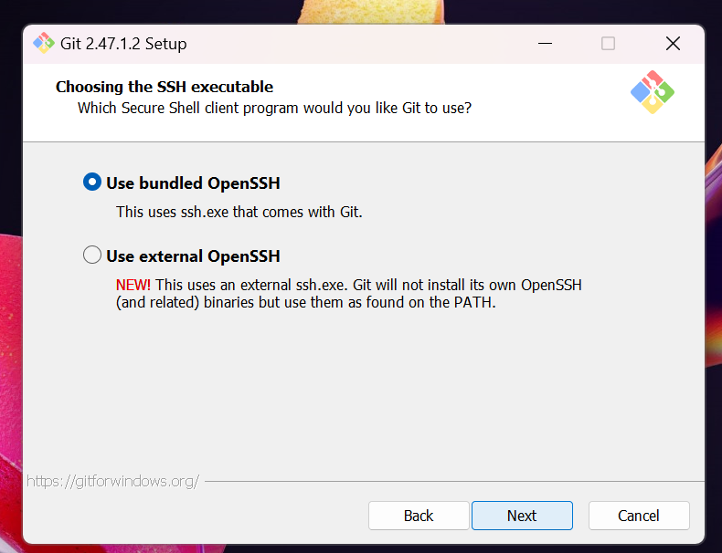

Step No. 12:

* Then you can choose which library can be used.

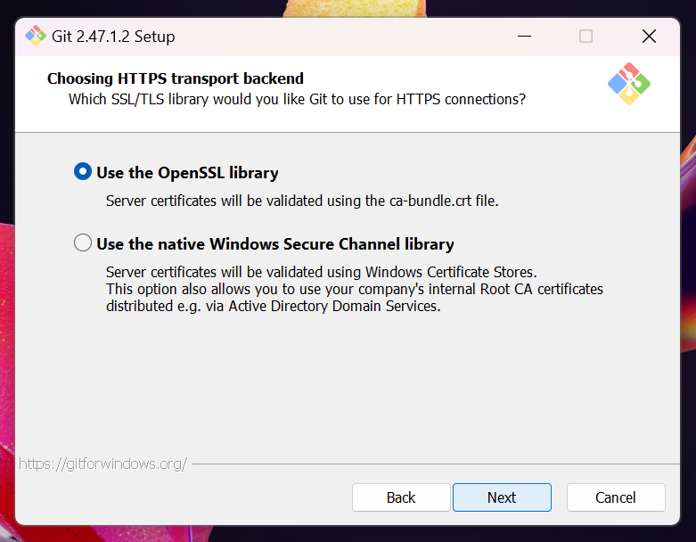

Step No. 13:

* Here the lines that are in text file are configured.

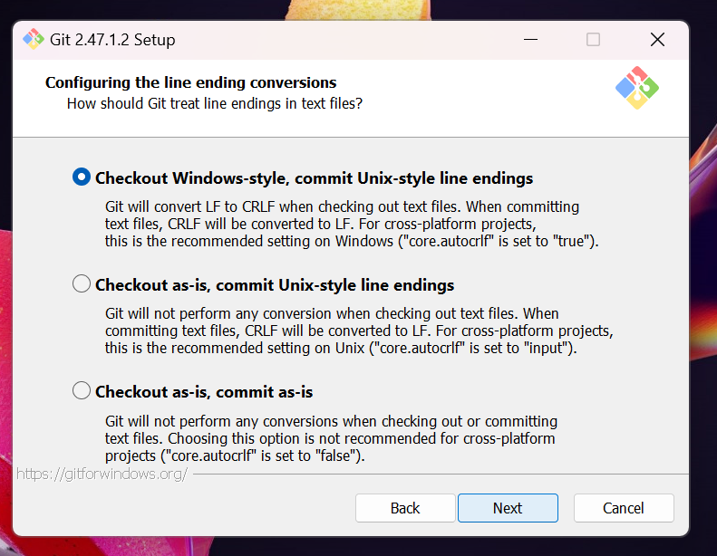

Step No. 14:

* You are asked to choose the terminal.

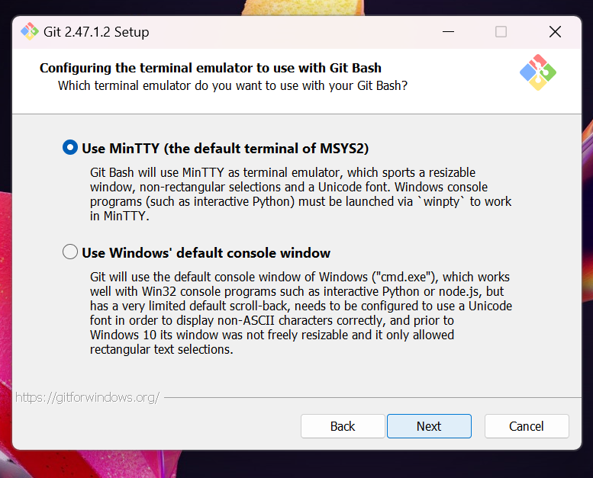

Step No. 15:

* Now you choose how the data is fetched from other branches.

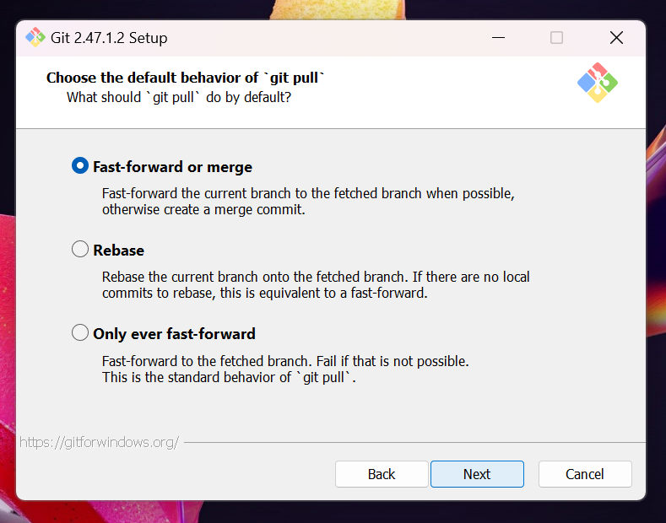

Step No. 16:

* Then you’re choosing the credential manager.

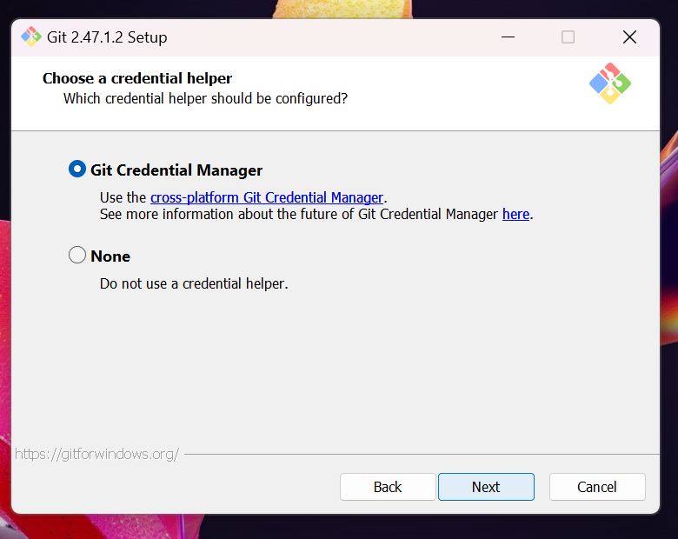

Step No. 17:

* Now all other features are asked to be choosen.

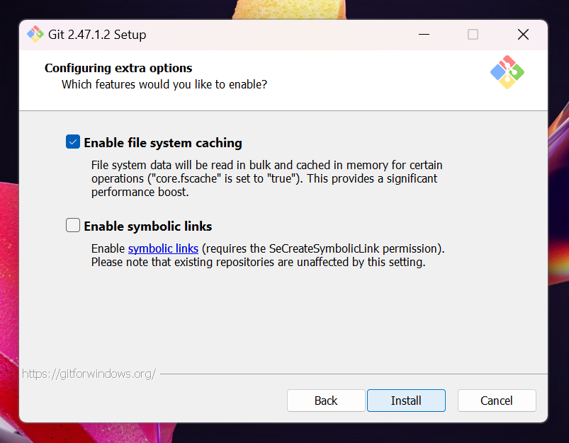

Step No. 18:

* Here the “git” is being installed.

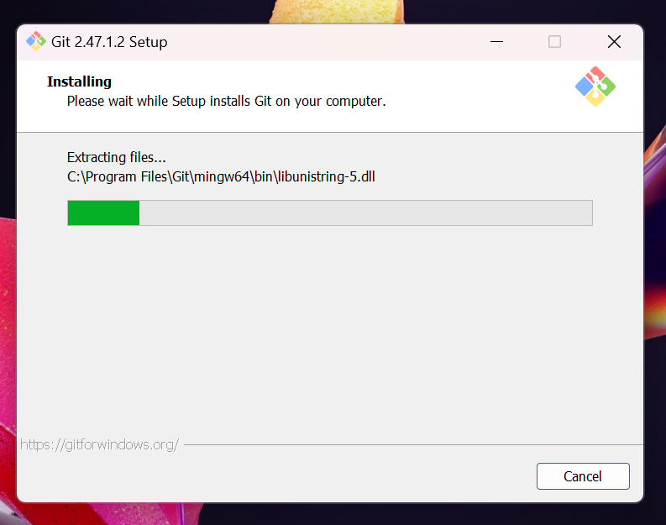

Step No. 19:

* Now the git is being launched.

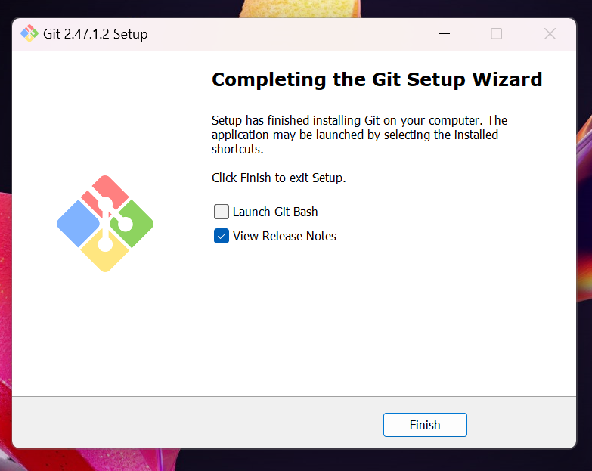

Step No. 20:

* Then after you are taken to git tutorial page.

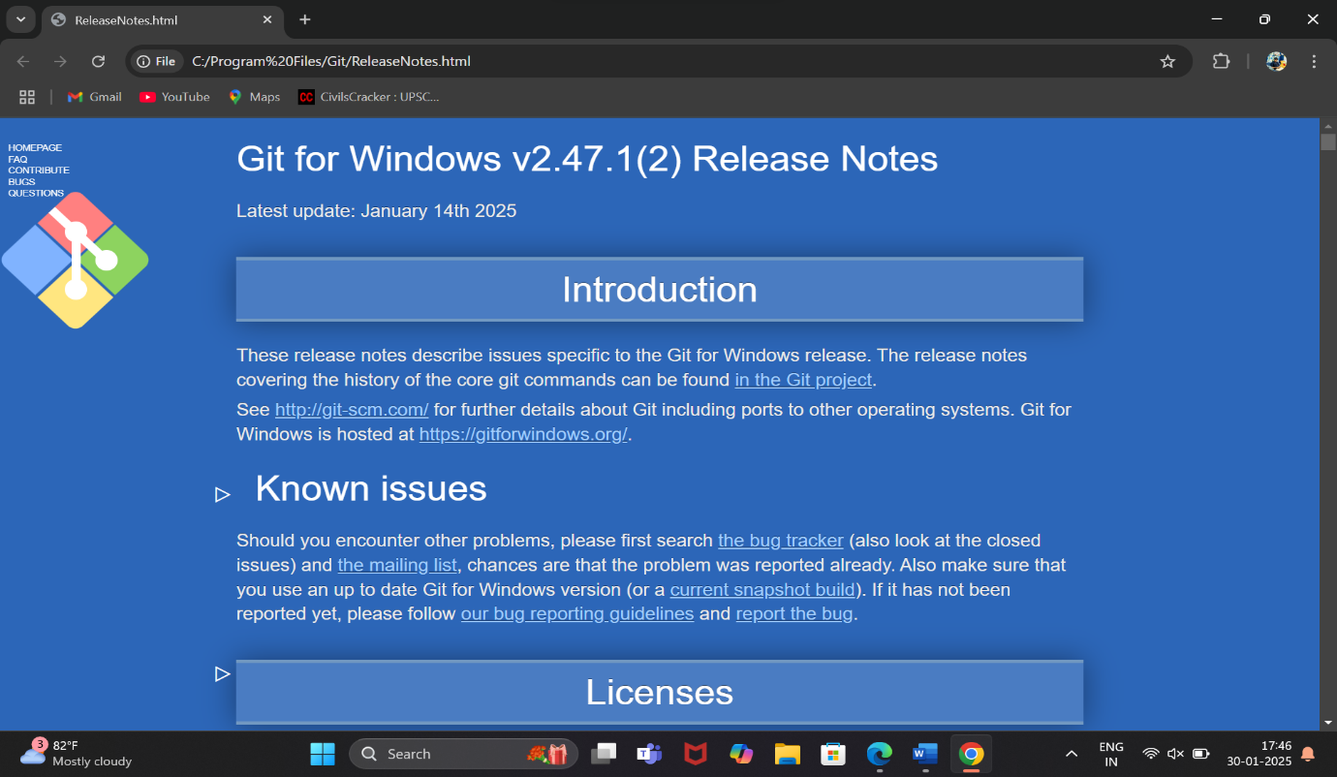

Now you can go search “Git Bash” on your windows.

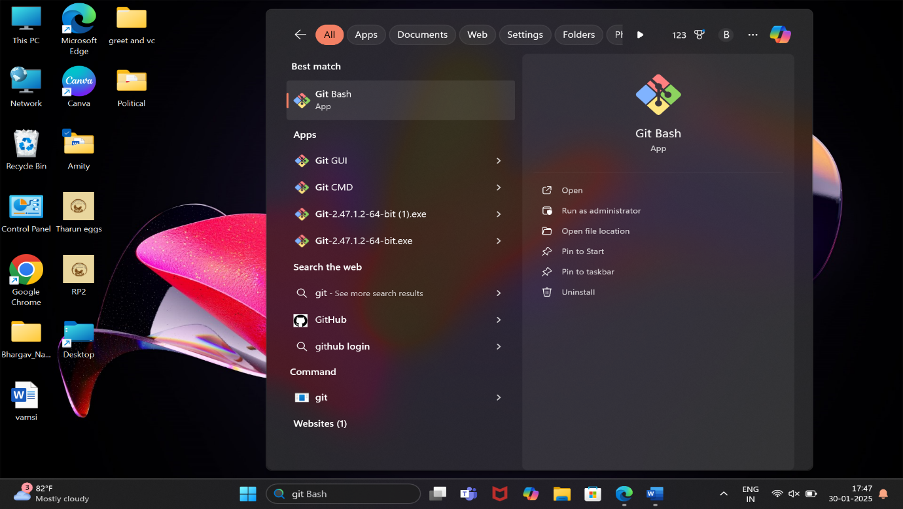

Then you can start coding once the screen below is opened.

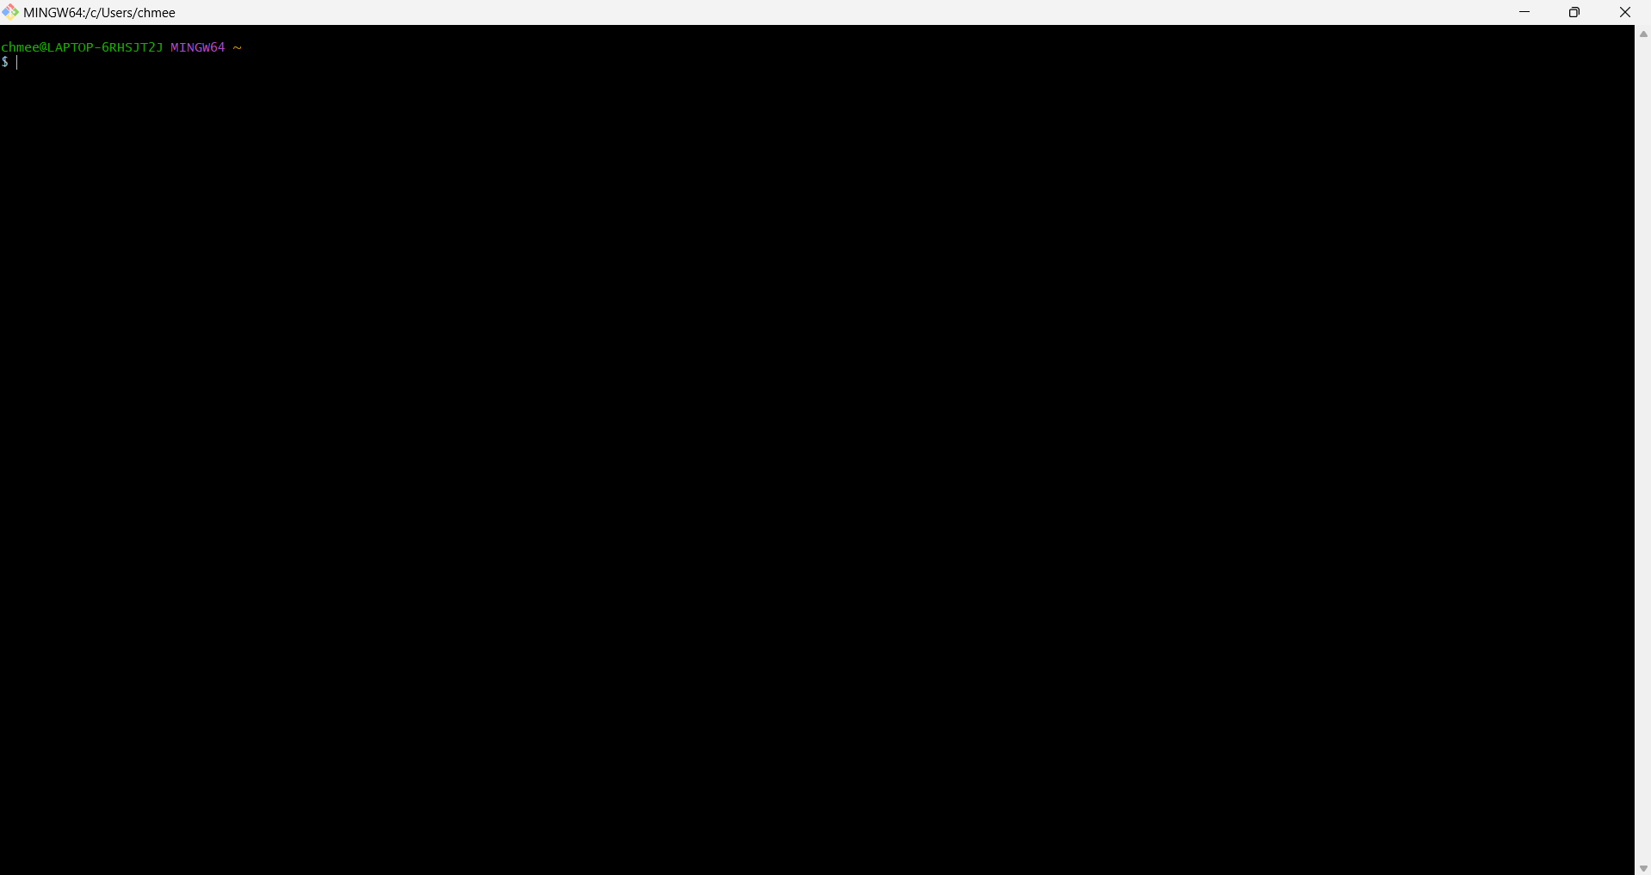



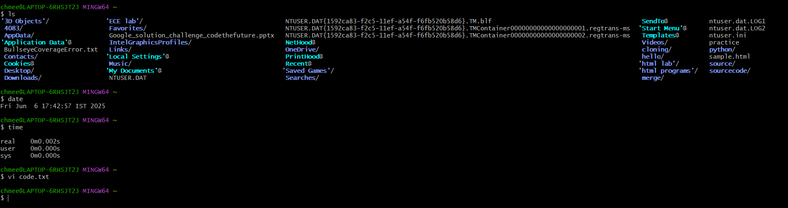

* Now, we will use a command called “vim”.

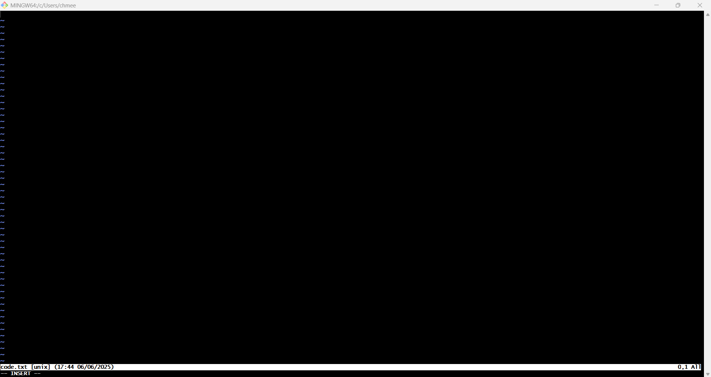

Date:6 February 2025

* Using different commands on the Git.

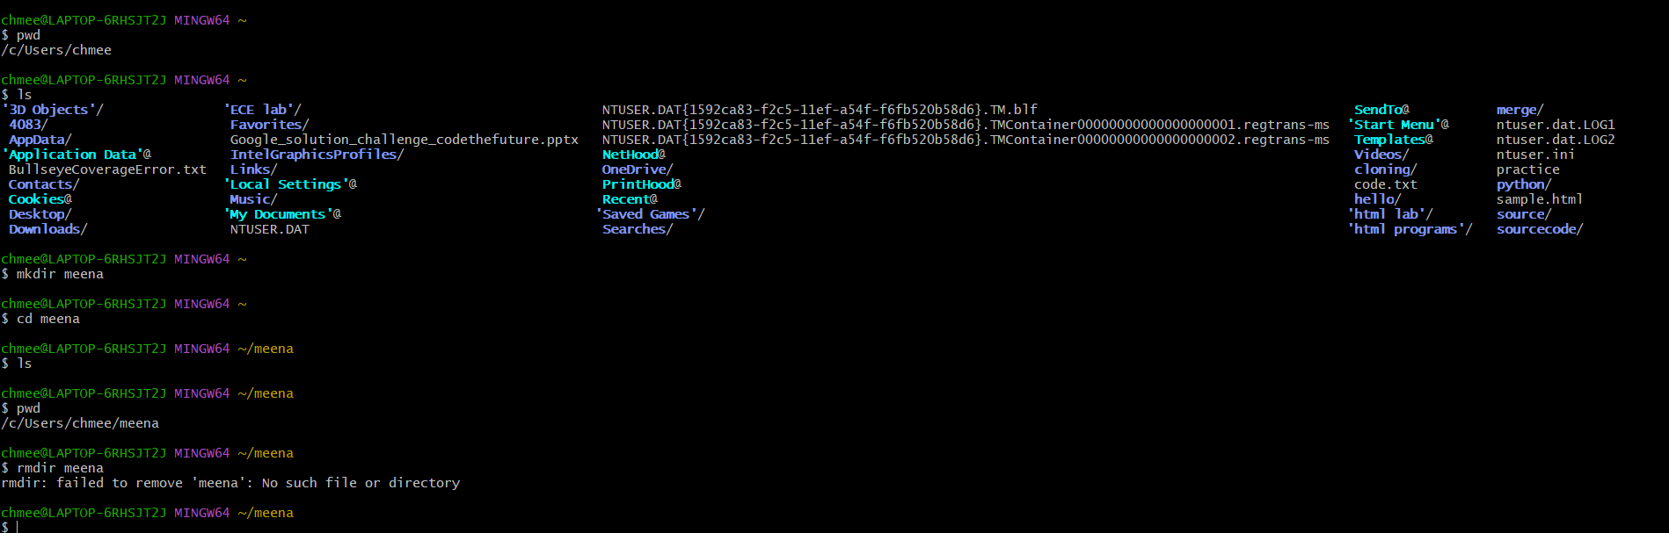

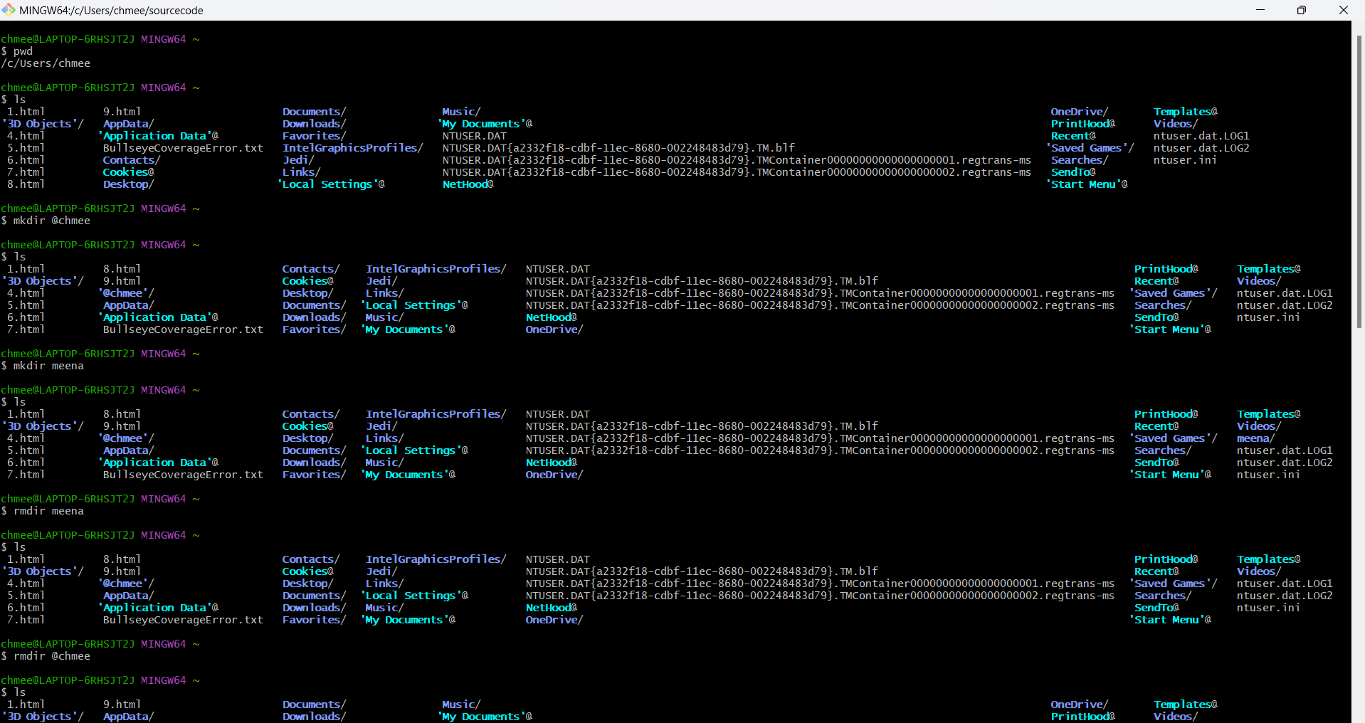

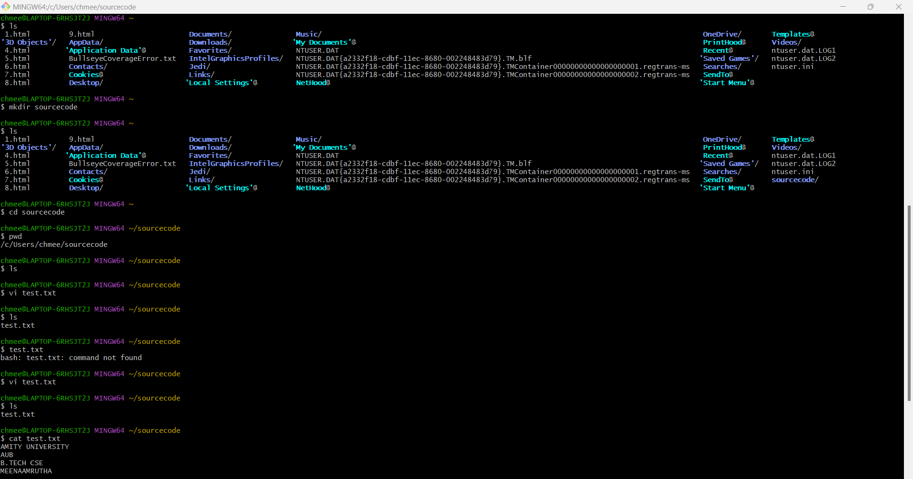

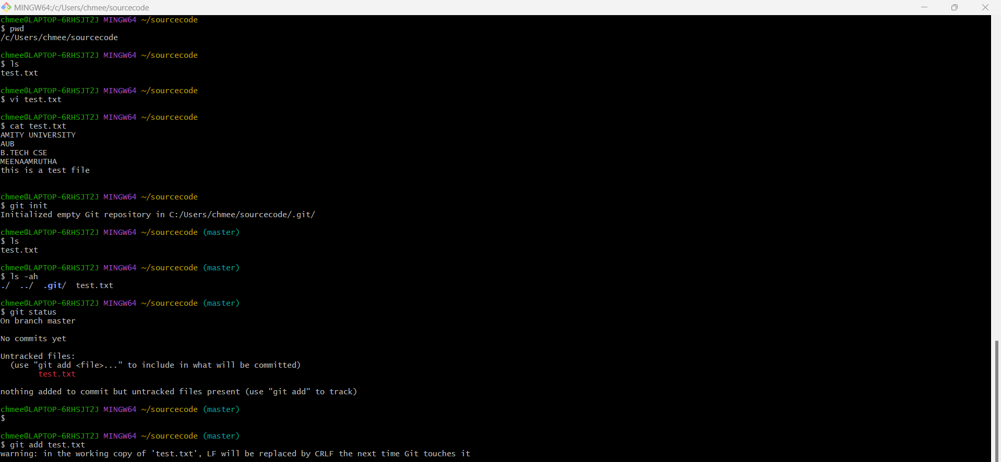

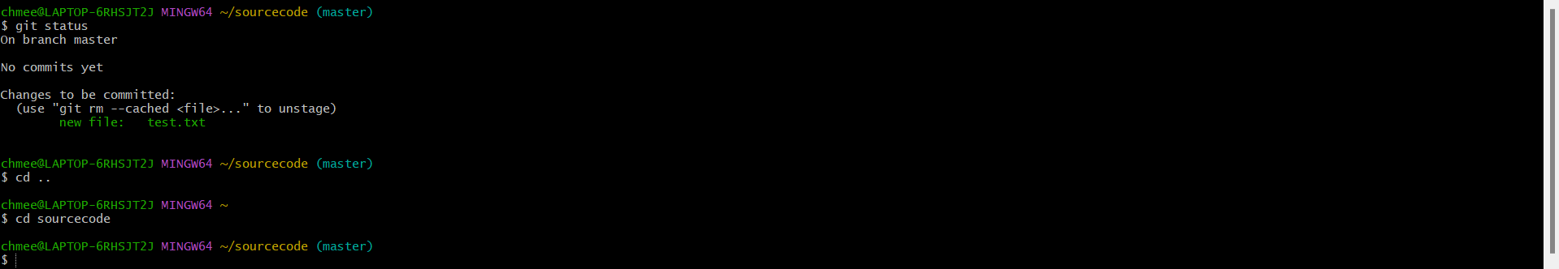

Date:13 February 2025

* Using Multiple commands including git status and git init

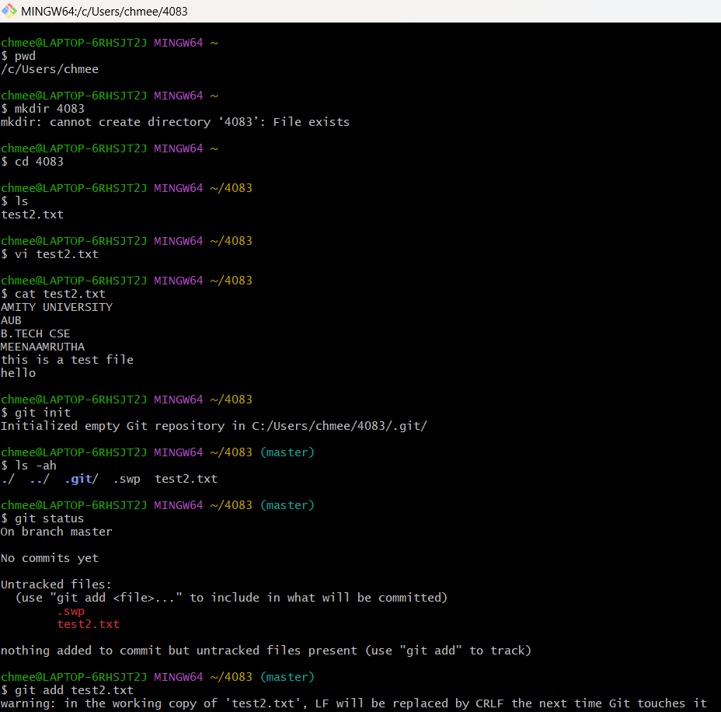

* Making Commits in Git

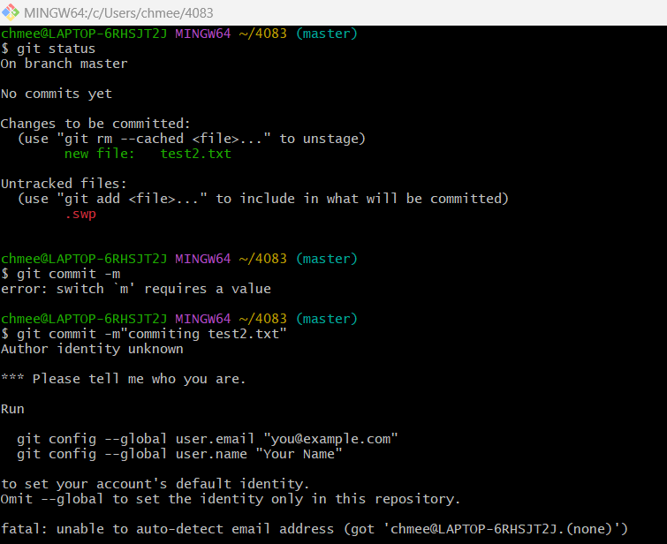

* Linking git bash to Git Hub account

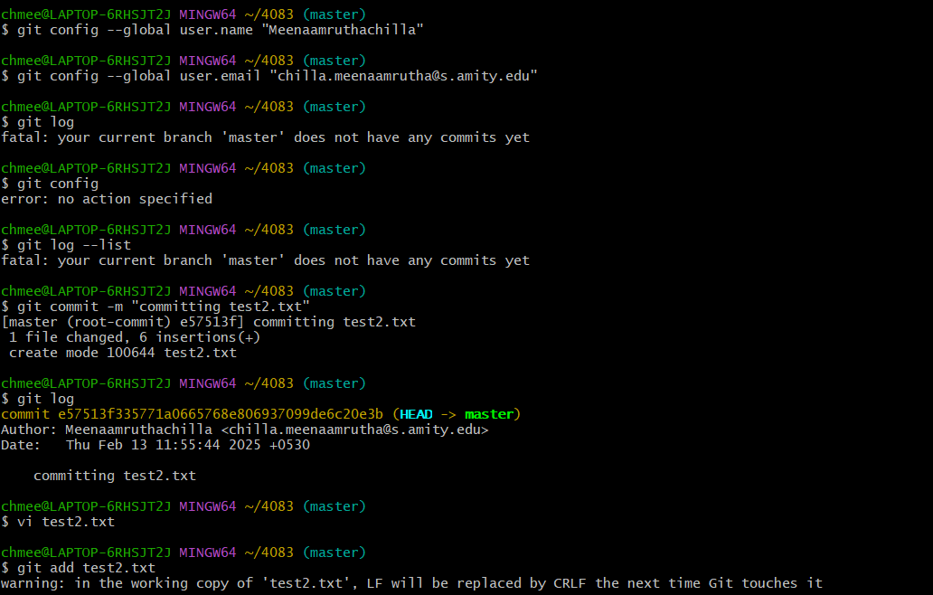

* Git log --oneline

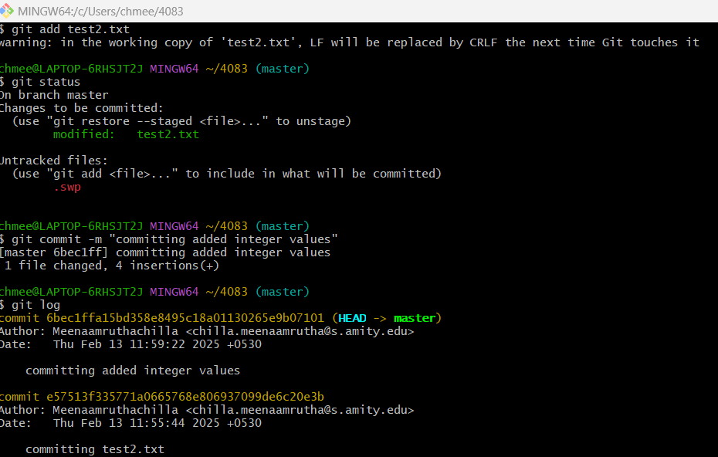

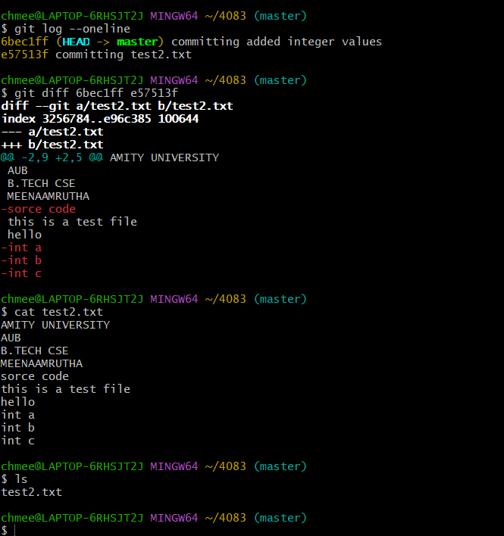

Date:27-02-2025

* Creating a repo and doing commits and pushing it to git hub profile

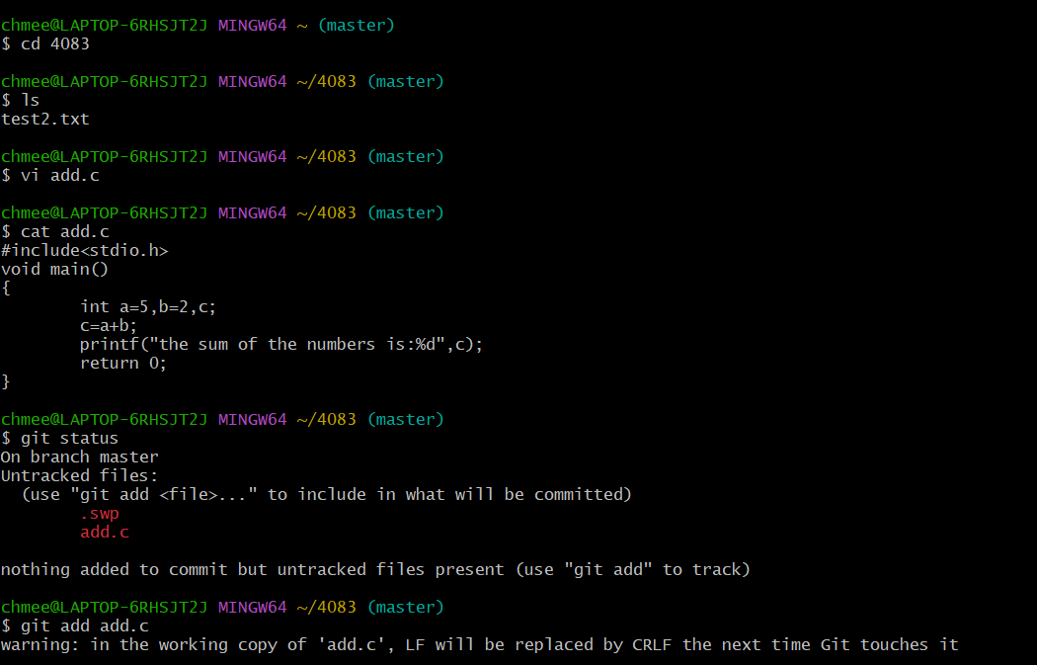

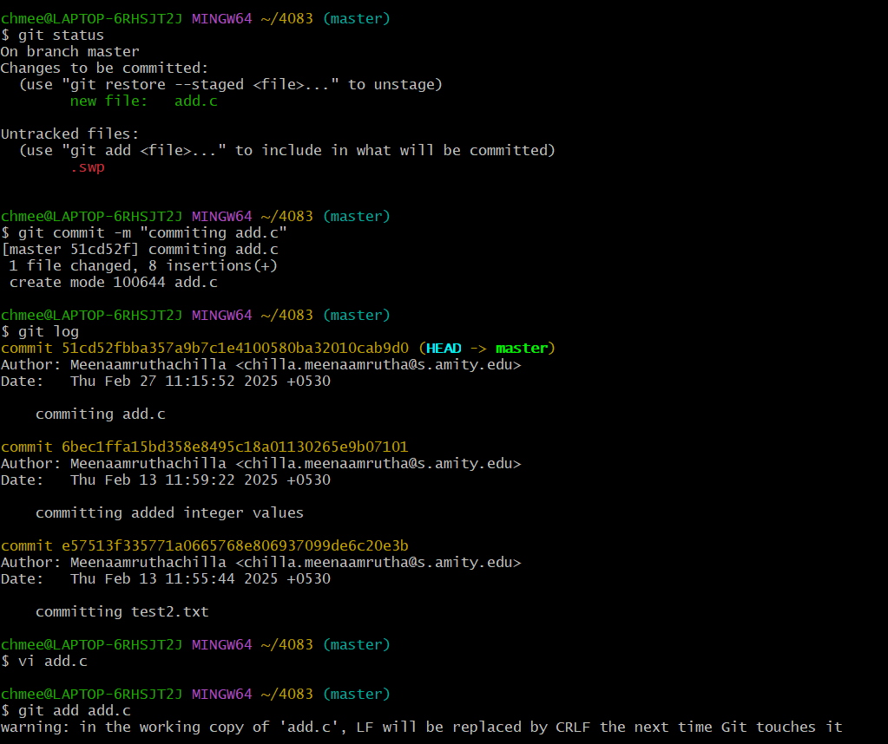

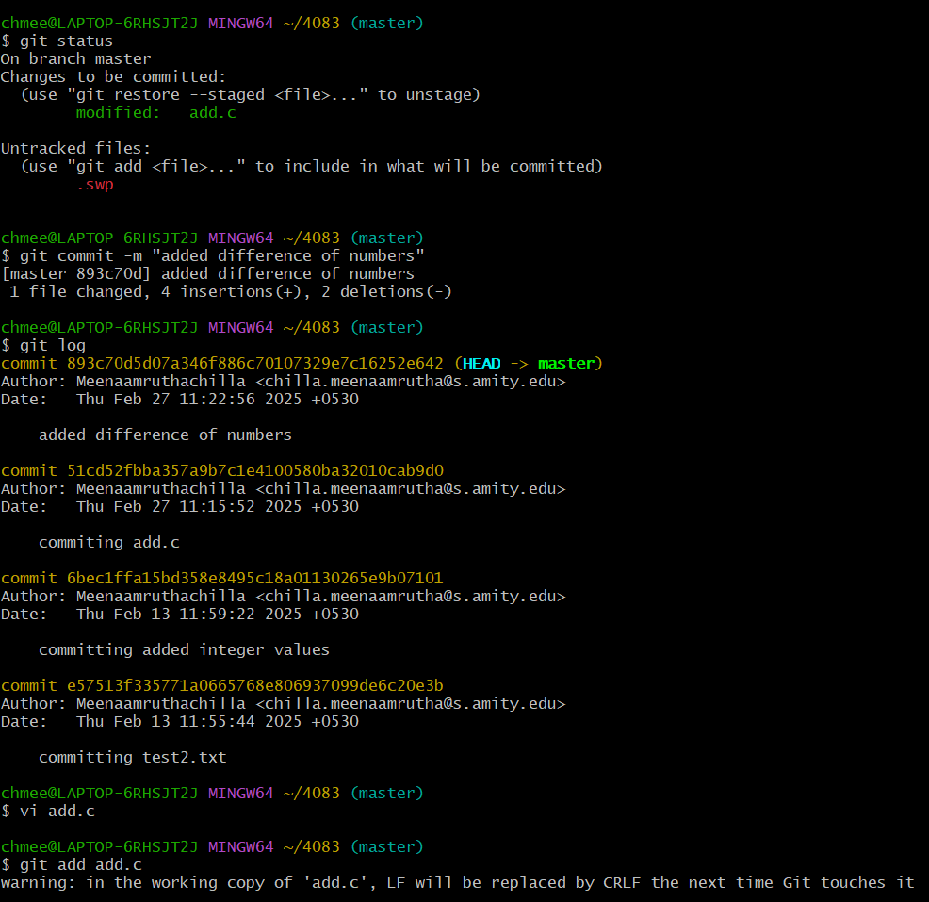

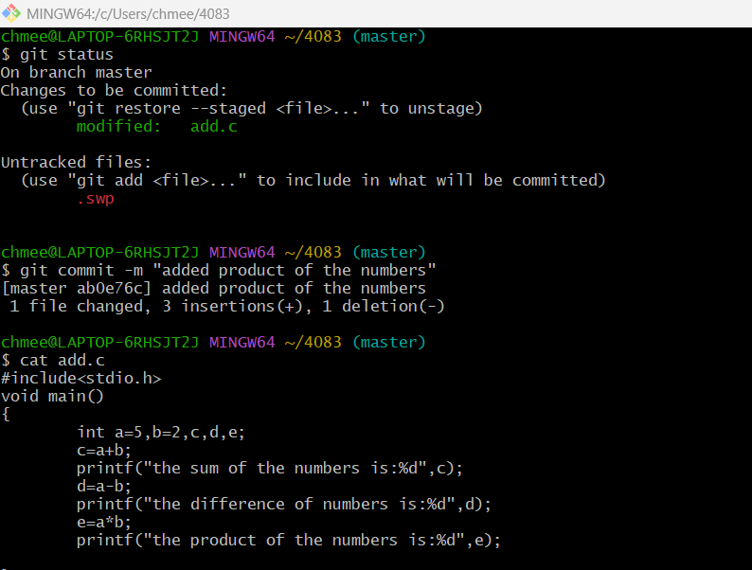

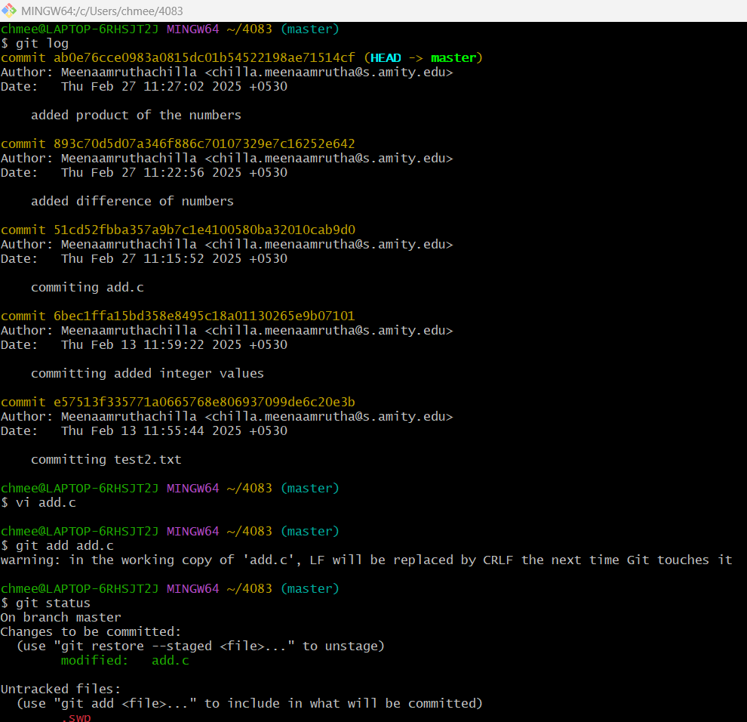

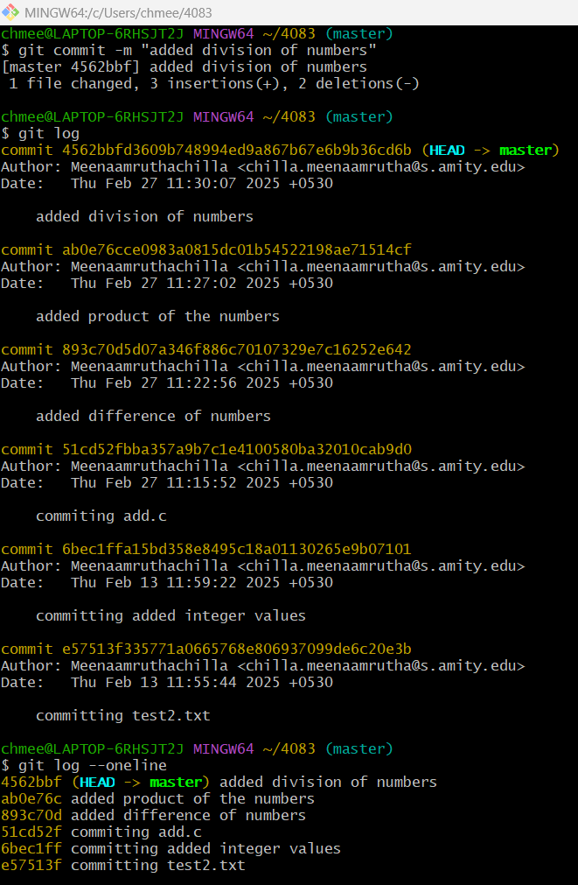

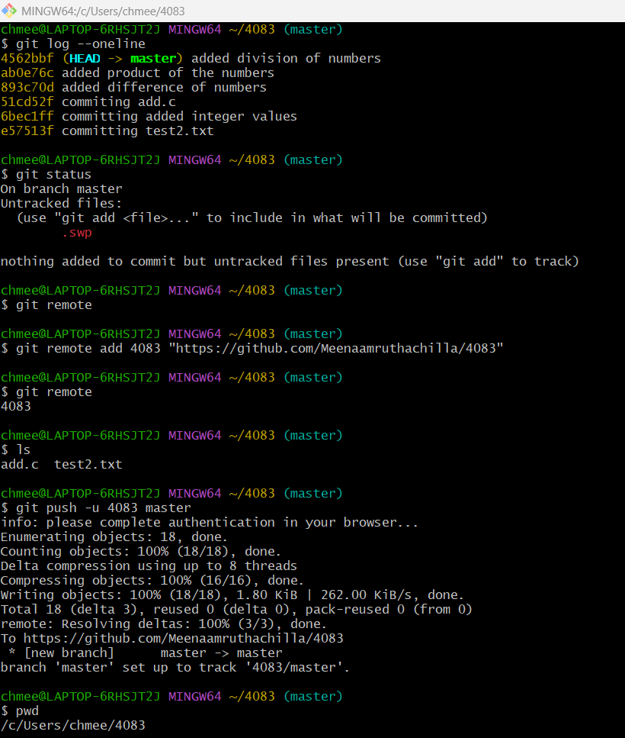

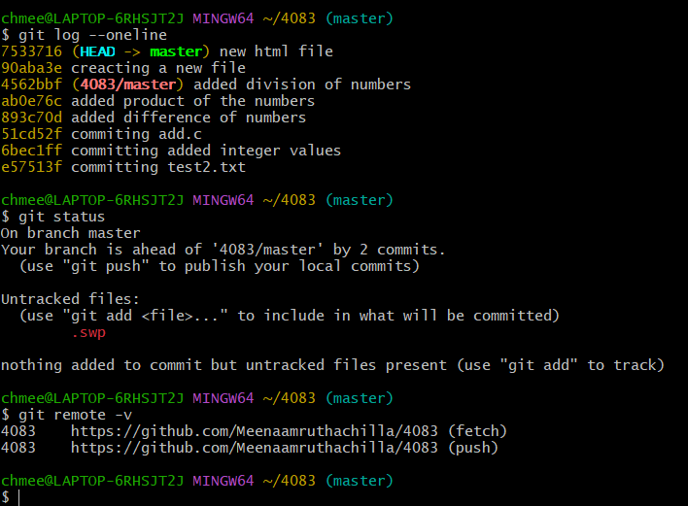

Date:27 march 2025

* Doing commits in different branches and merging both branches

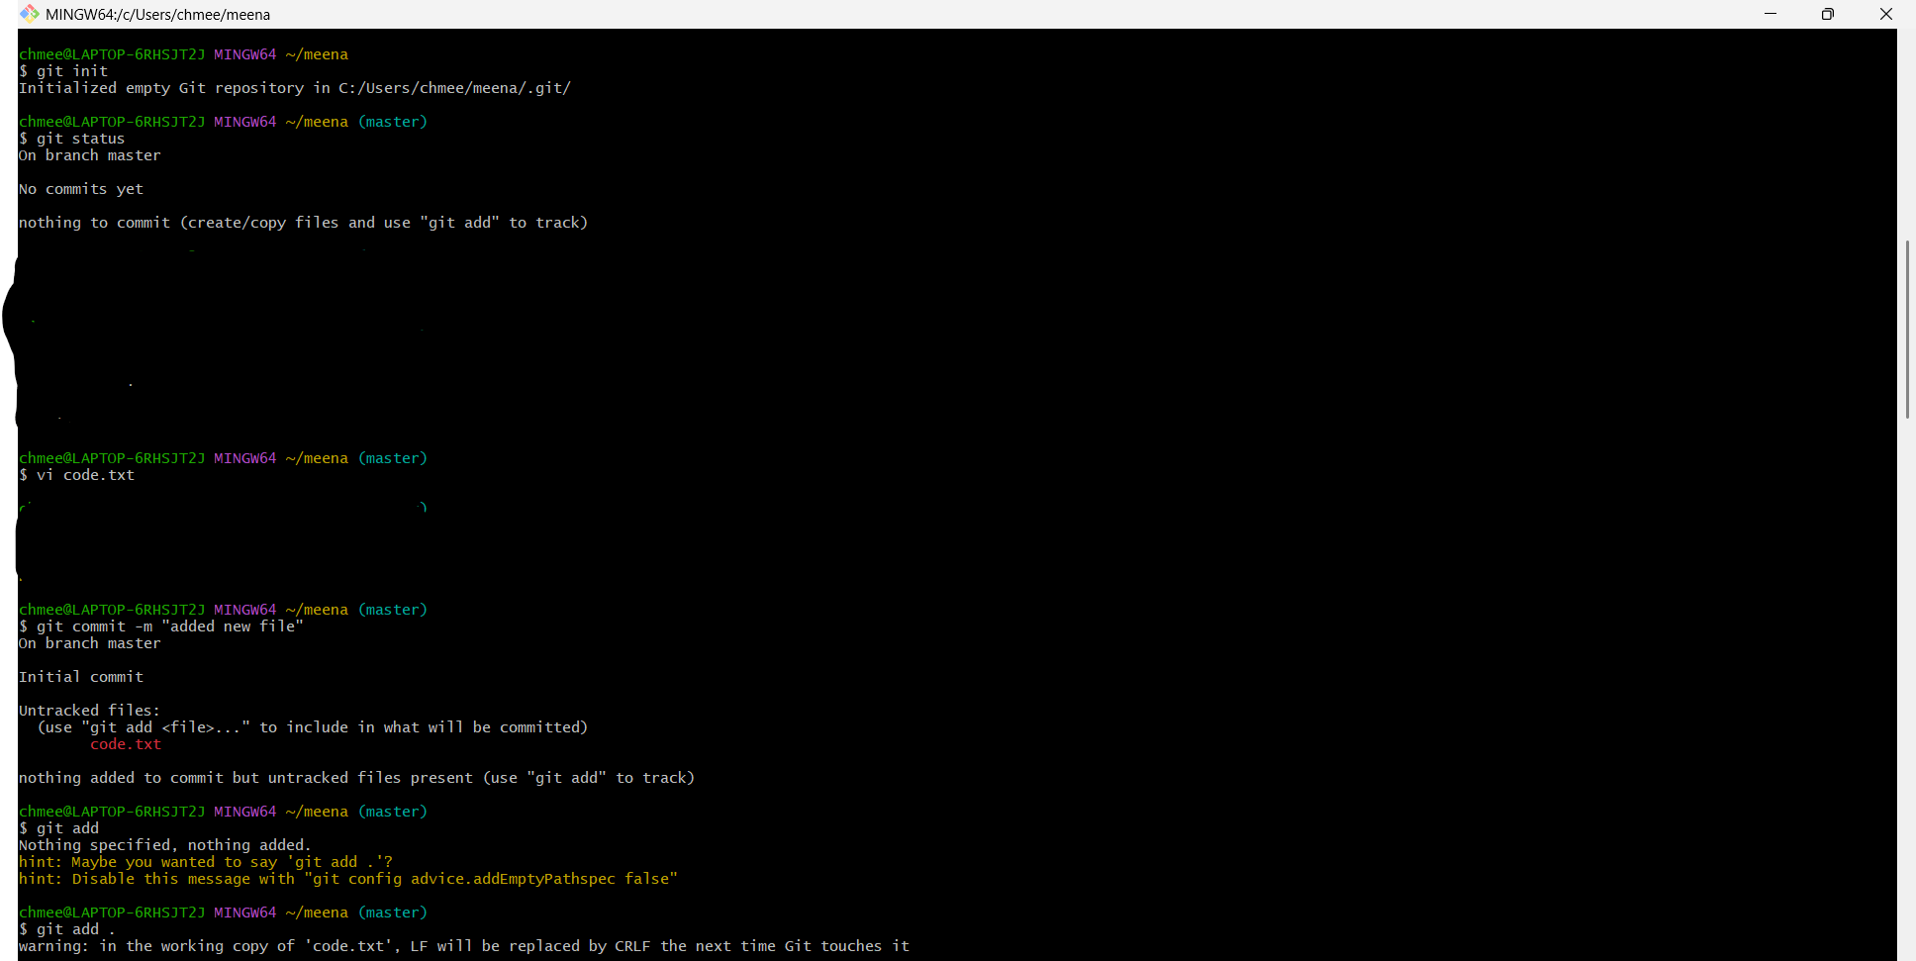

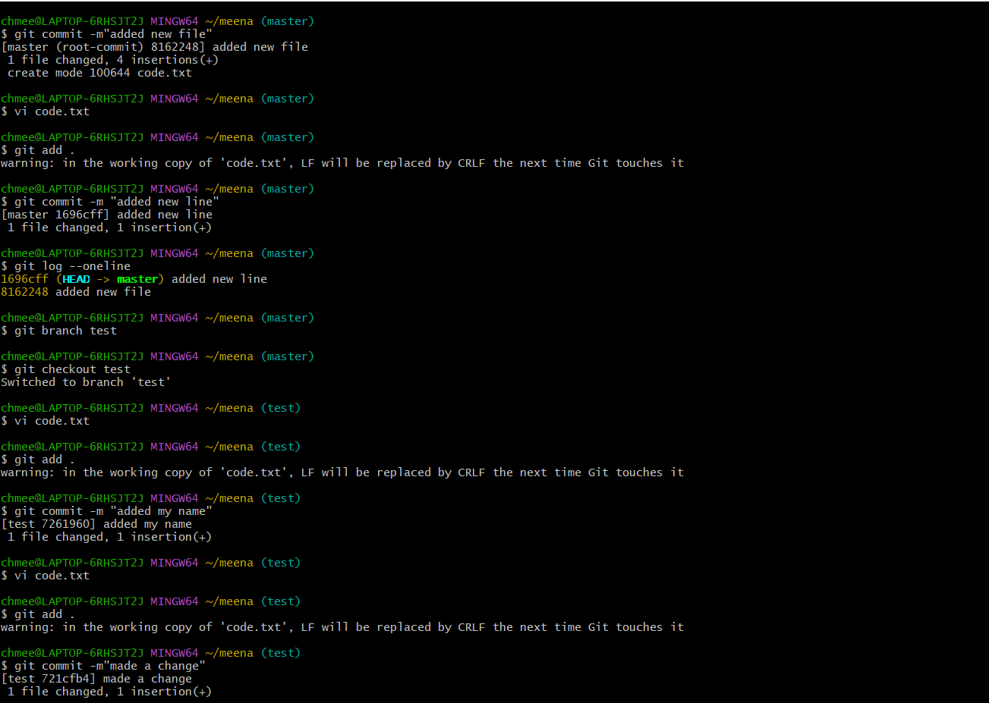

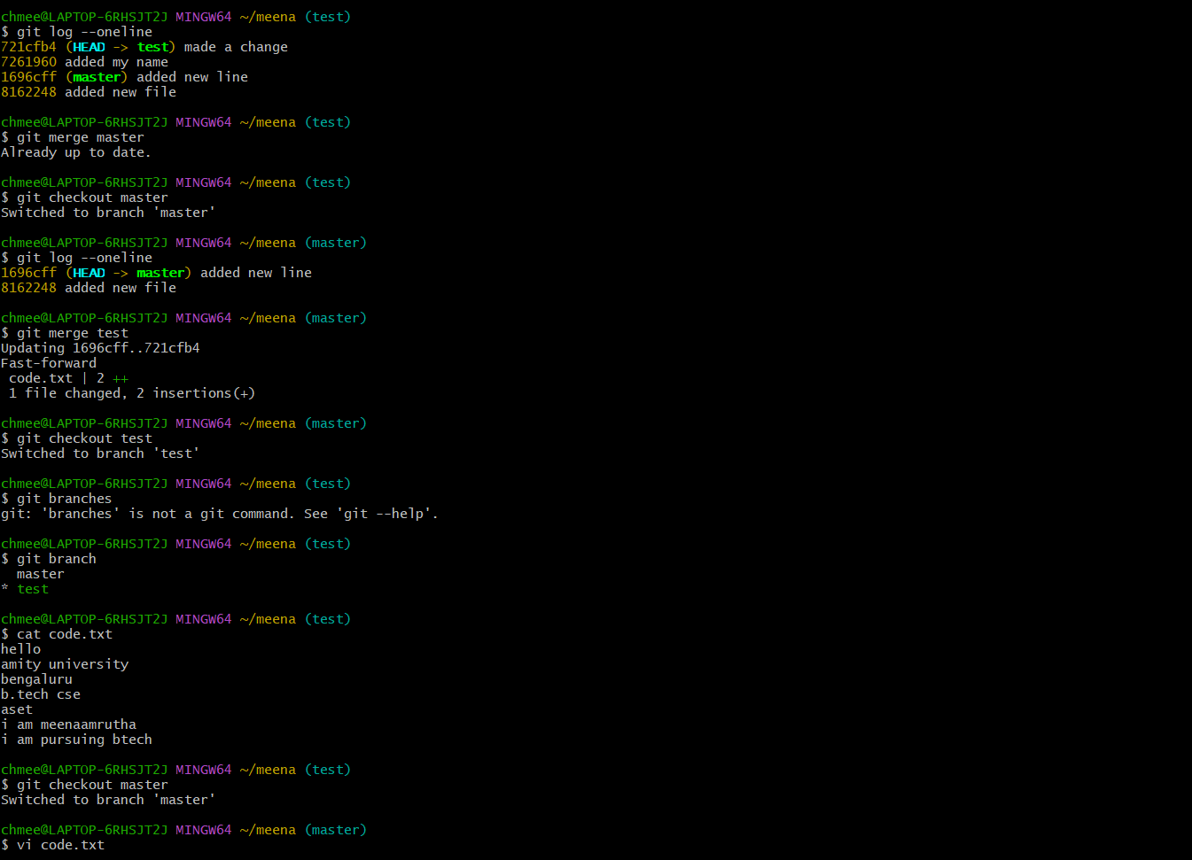

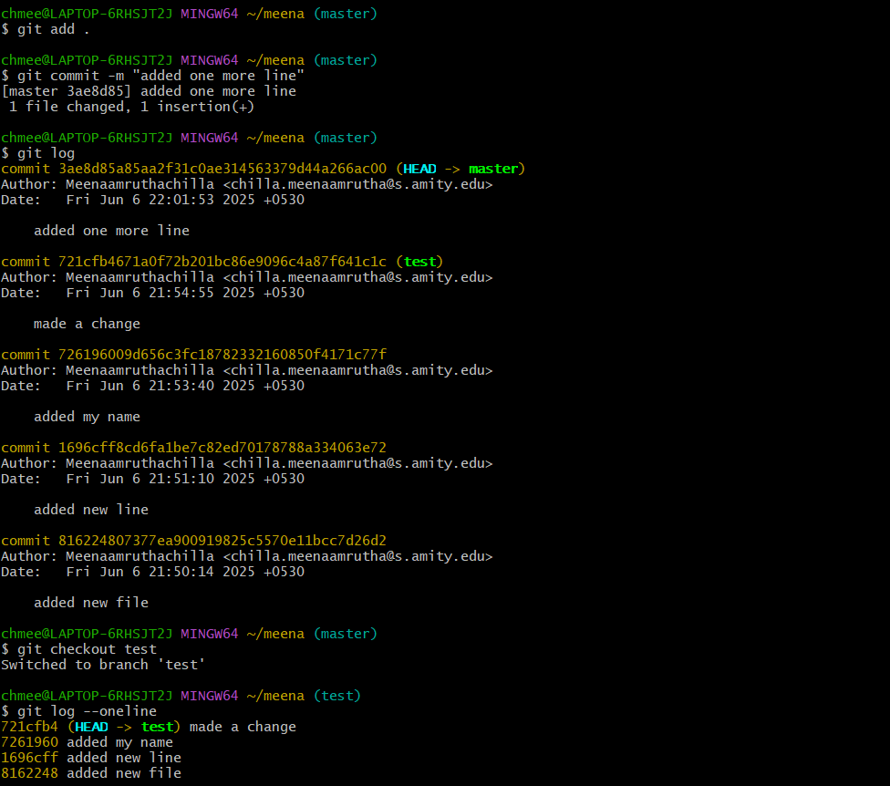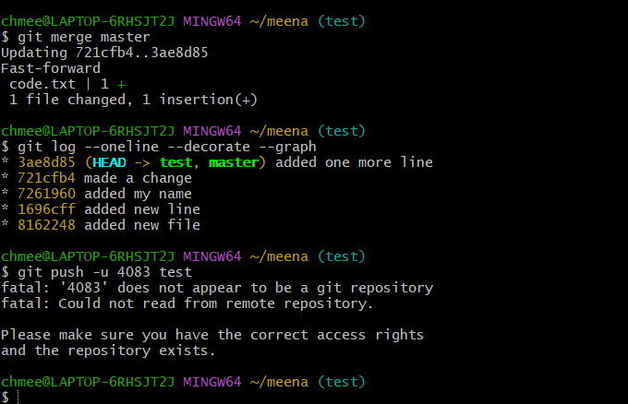

SCM-Project

* Creating a repository

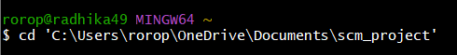



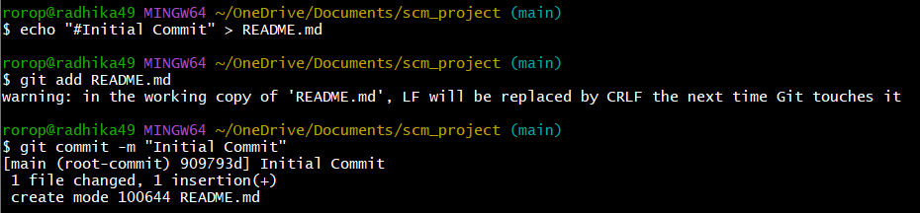

* Creating new branches for the project

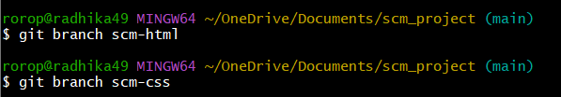

* Adding html and css pages of the project

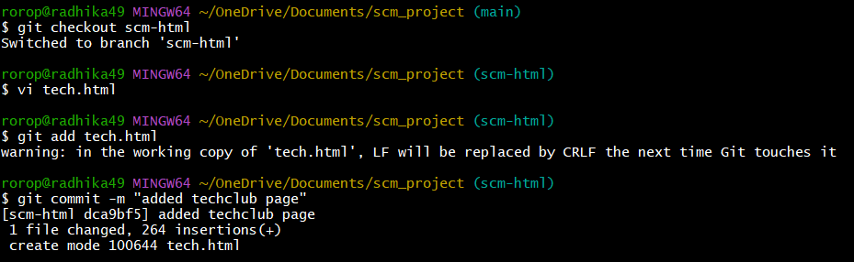

* Making commits in html and css pages

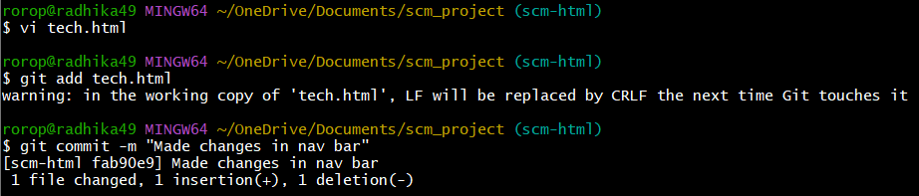

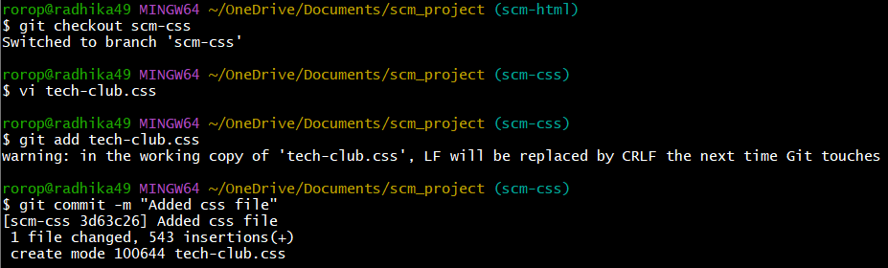

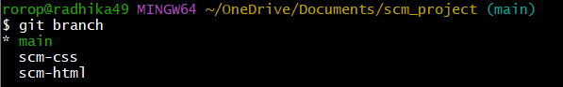

* Merging the html and css branches

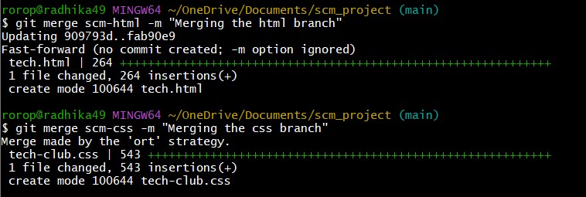

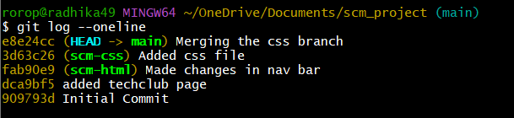

* Pushing everything into github

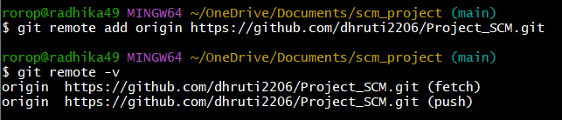

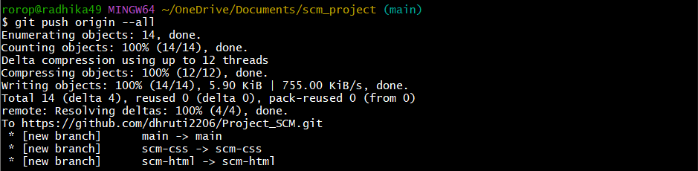

* Creating individual repo’s for all team members and making changes in their pages and then committing them and also sending pull requests to their git hub account

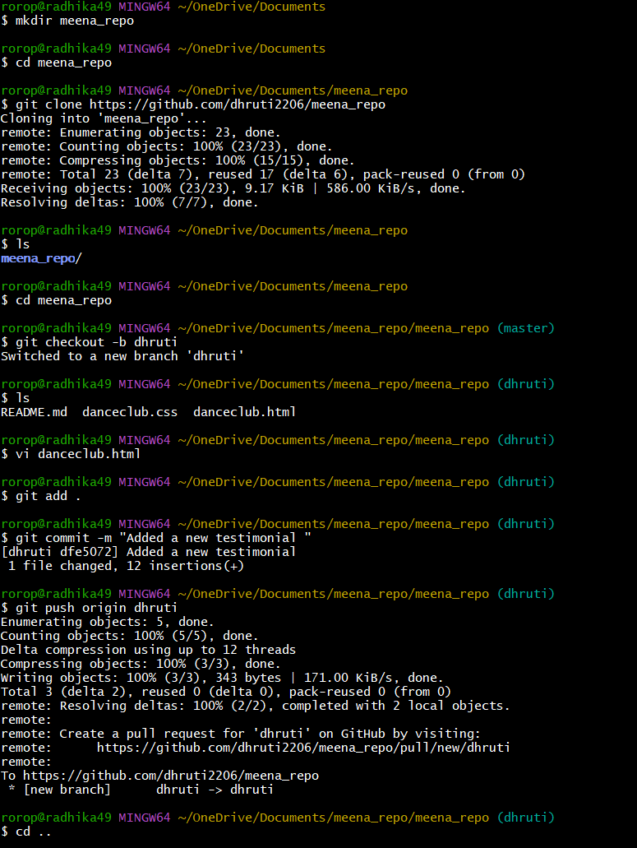

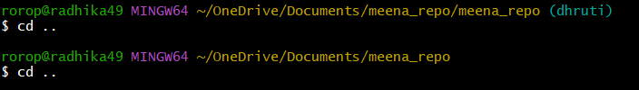

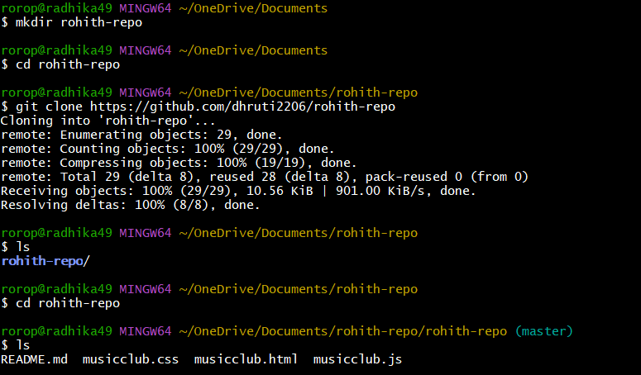

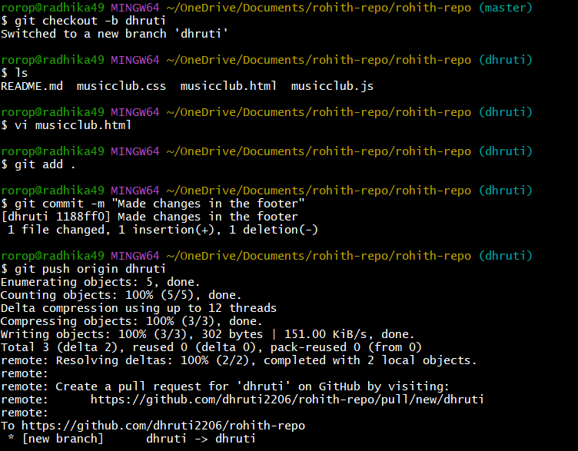

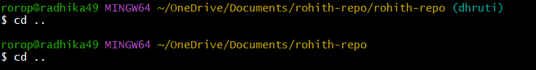

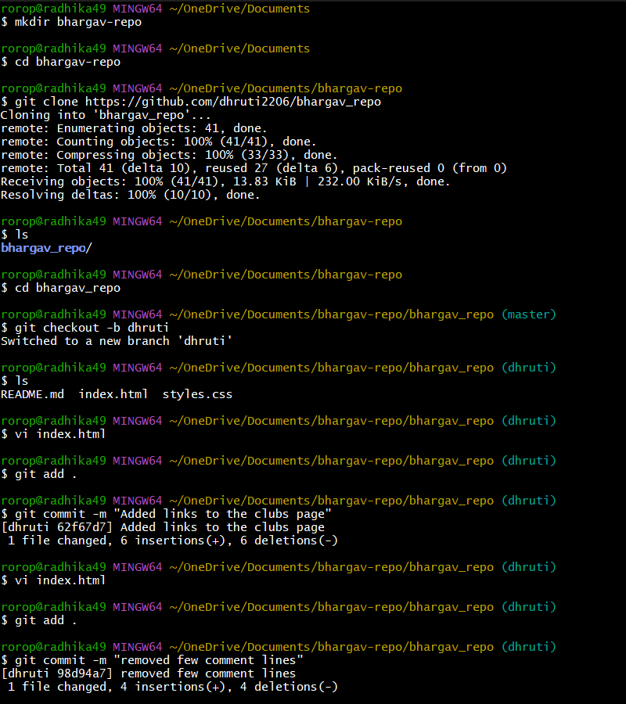

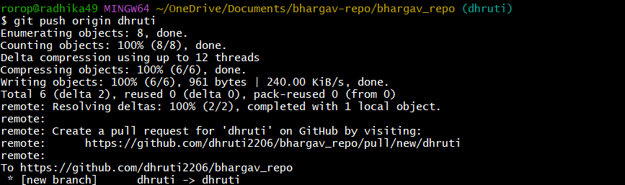

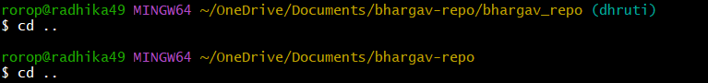

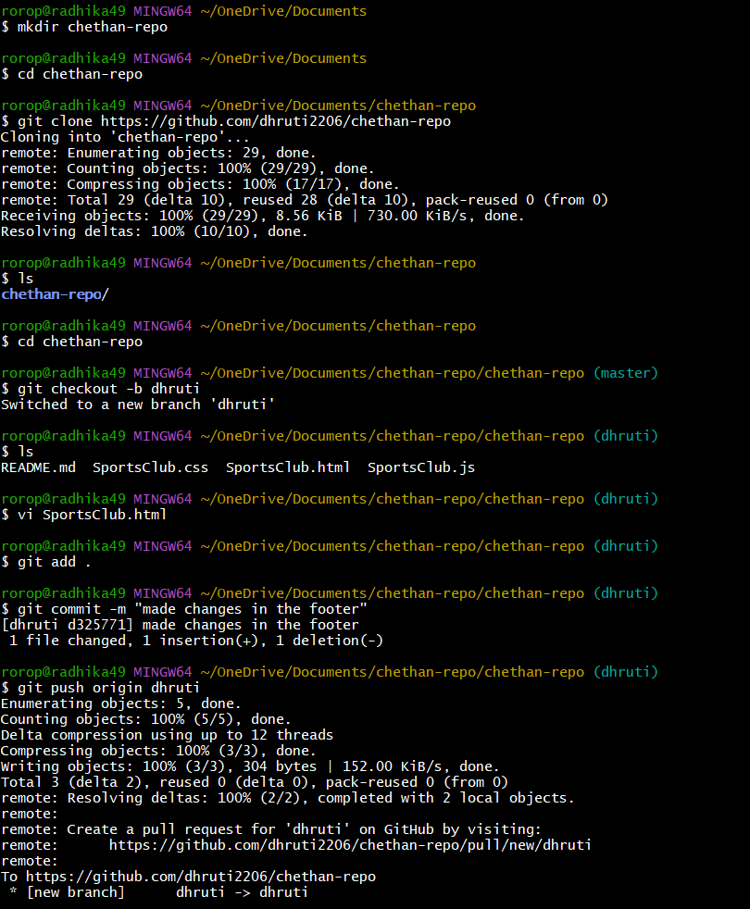

* **After doing this confirm and merge the pull requests**